**typeof**

typeof is used to return the type of specific data. It has two syntaxes: **1) Function syntax. 2) Operator syntax.**

**Note:** typeof typeof is a “**string**”

**Example 1:**

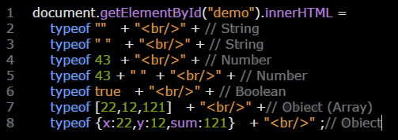

**Example 2:**

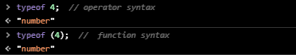

**Example 3:** typeof typeof is “string”

